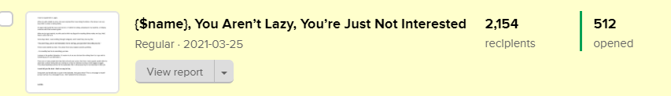
411 people opened this email : https://preview.mailerlite.com/b5d7x4

-----------------------------------
{$name}, you Aren’t Lazy, You’re Just Not Interested

{&name},

I have an apartment in Lagos.

When my wife visited me once, she was surprised that I was doing the dishes. She knows I am very lazy when it comes to doing dishes.

I’ll argue with myself for hours and not do it. I’ll rather be writing, preparing for my students, or helping someone with their business goals.

When we just got married, my wife used to think my disgust for washing dishes makes me lazy. Well, there’s some truth to it.

Some days back, I was scrolling through Instagram, and I heard Gary Vee say this;

“You aren’t lazy, you’re not interested. You’re not lazy, you just don’t love what you do.”

These words tickled my brain. This advice from Gary explains laziness perfectly.

{&name}, it’s incredibly hard to do something you hate.

Laziness is the perfect distraction. It’s easier to sit on your butt and do nothing than it is to go and do something you’re not interested in.

There are so many people who hate their job and even worse, their boss. Some people would rather be dead than continue doing their job. Getting out of bed on Monday morning is their biggest struggle. They dread weekdays and live for the weekends ONLY. All because they’re not interested in their job.

I must tell you the trust - that’s no way to live, {&name}.

Doing work you literally hate is a pain in the backside. And guess what? This is a message to myself just as much as it is a message for you. I don’t pretend to be some guru.

Lamide.

